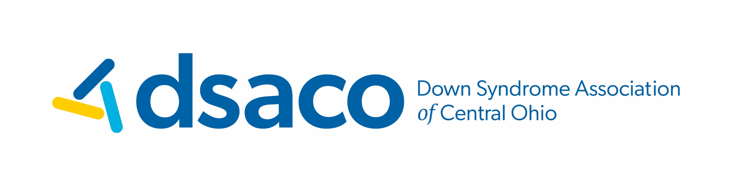
Community Access Fund Guidelines
DSACO’s Community Access Fund provides financial reimbursement to individuals with Down syndrome for funds spent on inclusive activities in the community. These activities may include, but are not limited to sports, swim lessons, gym memberships, personal trainer, summer camps, gymnastics, martial arts, education-based apps, auditing college courses, physical/speech therapies (as prescribed), dedicated communication devices, speech camp, art, music, dance, instrument, voice lessons, theater classes.* Funds are not intended for DSACO programs such as iCan Bike, iCan Swim, and SLA or for private tutoring (which is now provided through Learning Aid Ohio).
*Music and Performing Arts activities are generously funded by the Barbour family in memory of Ann Barbour.
Eligibility:
The individual with Down syndrome must be a member of DSACO.

How do I become a DSACO member?
DSACO’s service area includes twenty-three Ohio counties: Athens, Coshocton, Delaware, Fairfield, Fayette, Franklin, Gallia, Hocking, Jackson, Knox, Lawrence, Licking, Madison, Marion, Meigs, Morgan, Morrow, Muskingum, Perry, Pickaway, Ross, Union, and Vinton. Additionally, we have extended support to families who live in Pike, Scioto, Logan, Hardin, Crawford, Richland, Guernsey, and Washington counties.
To fill out a membership form, go to www.dsaco.net/membership. Membership is free!

Submission Process:
Reimbursement happens quarterly based on the deadline schedule below:
Q1 | Submit form with receipts by March 15 for payment by March 31
Q2 | Submit form with receipts by June 15 for payment by June 30
Q3 | Submit form with receipts by September 15 for payment by September 30
Q4 | Submit form with receipts by December 15 for payment by December 30

To apply, complete the application online www.dsaco.net with attached receipts. *Applications submitted without the receipt of payment will be considered incomplete and will not be processed.

Annual Maximum:
The maximum amount of reimbursement per individual per fiscal year is $250.00. DSACO’s fiscal year begins January 1 and ends on December 31. The program is operated on a first come, first serve basis until funds are exhausted.

Awarding Funds:
Once an application is approved and processed, you will receive a check via USPS. If the application is denied, a brief explanation will be included in the written notification.

Requests may be denied for the following reasons:
- Requestor has already been awarded the annual maximum of $250
- Activity does not meet criteria guidelines
- Community Access Funds have been exhausted for the current fiscal year
With questions, please email info@dsaco.net
01/03/2023

